Project Requirements

This is a group project that must be turned in by the start of the next class. You will be building an animal adoption site.
- Create a single database with 2 tables Animals and Adopters.
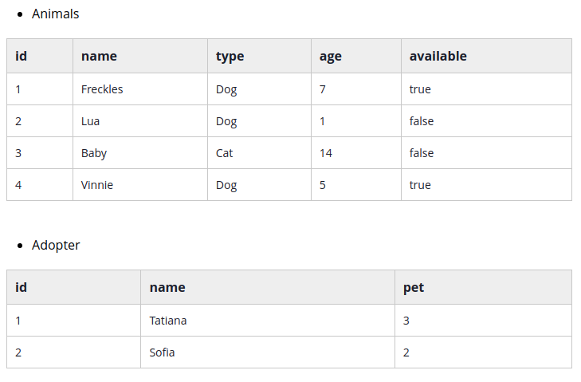
The pet_id is a foreign key to the id of the Animal that was adopted.
- Build an Animal search service that GETs available animals by Type and Age range and updates the available status of Animals (use PUT or PATCH).
- Build an Adopter service that POSTS adopters and their associated Animal id.
- Build an edge service that allows users to search for available animals and adopt an available animal.
- Build a nd that has the following features:
  - Search for animals by type, age range, or both.
  - Display all animals matching the user’s criteria with an adopt button beside each
  - When the adopt button is clicked, display an adoption form that asks for the user’s name.
  - On form submit, enter the user and pet_id in the Adopter table and update the available status of the pet.
If you finish early polish your frontend, add more animal features (pet-friendly, good with kids, health issues, breed, etc), and build a more advanced search.

